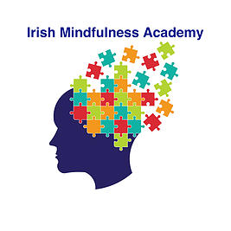Consolidate your Knowledge - Month 6 - Group 4

Name:

1. During the enuiry stage after the Loving Kindness meditation a class member tells you they feel really bad, whereas before that they were feeling very good in themselves. What response would you give them?. (Minimum 250 words).

2. How would you explain 'Experience Dependent Neuroplasticity' and how to practice it to your class? (Minimum 250 words).
.

3. Describe the functions of the Amygdala and Pre-Frontal Cortex? Also what happens to both as a result of mindfulness practice (Minimum 250 words).

4. Describe 3 difficult classroom situations you may encounter in your class and how you would handle them.. (Minimum 250 words).

