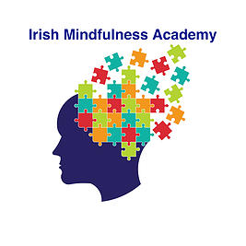Consolidate your Knowledge - Month 6

1. What does trait Mindfulness mean?

2. Why is it important to allow space and silence in the class?

3. Explain self-directed neuroplasticity.

4. What percentage/fraction of our psychological wellbeing is from genetics versus conditioning/learning?

5. Explain brain structure in using the analogy of 'the house'.

6. List some teaching points for the Lake meditation.

